Tyler Technologies

Database Server Troubleshooter

Software Requirements Specification Document

*By David Bergman, Judson Hayes and Josh Powell*

Contents

1. Introduction 3

2. Specific requirements 3

2.1 Interfaces 3

2.1.1 User Interface 3

2.1.2 Server Interface 4

2.2 Functional Requirements 4

2.2.1 Input The input for this application other than pressing the start button and giving administrator credentials is entirely server side. 4

2.2.2 Process 4

2.2.3 Output 4

2.3 Performance Requirements 4

2.3.1 Download & Install Speed 4

2.3.2 Overall Performance 5

2.4 Design Constraints 5

2.4.1 Microsoft 5

2.4.2 .NET 5

2.4.3 ClickOnce 5

2.5 Additional Attributes 5

2.5.1 Connection Speed 5

2.5.2 Security 5

2.5.3 Documentation 6

# 1. Introduction

The following described project is commissioned by Tyler Technologies. The purpose is to create a database diagnostic tool, using a click-once interface, that will gather real-time information regarding a database server. The product will display the information in a easy to interpret graph view, and have the capability to export the information to a pdf. The servers being developed for will be 2012 microsoft sql engines.

# 2. Specific requirements

This section contains all of the functional and quality requirements of the system. It gives a detailed description of the system and all its features.

## 2.1 Interfaces

This section will detail the two Interfaces we have in our project the user interface, and the server interface. The user interface and the interface between application and back-end server.

### 2.1.1 User Interface

The user should launch the application to find the first screen of the application which will include a begin scan button and possibly a login credentials text area. Figure 1 below will showcase this.

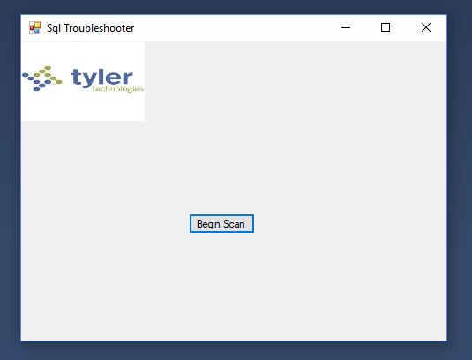 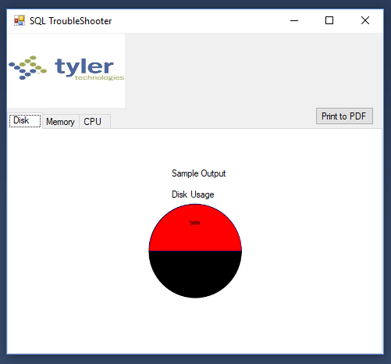

Figure 1- Initial Begin Scan Screen Figure 2- Result of Scan

The second screen of the user interface is the display screen. This screen has three separate tabs that display data based on if it is on the, Disk, Memory, CPU, tabs. As well as having a “Print to PDF” button that extrapolates data from the three tabs and prints it to a PDF

See Figure 2 above to showcase this.

### 2.1.2 Server Interface

The application will connect to a sql server, and query data from it to extrapolate data. One the data has been extrapolated, the data will include the Disk Space, Memory Allocation, and CPU Usage. These data points will then be sent to the application and displayed through the user interface through adaptable graphs.

## 2.2 Functional Requirements

This section will cover the functions requirements of the project, such as input, process, and output.

### 2.2.1 Input The input for this application other than pressing the start button and giving administrator credentials is entirely server side.

### 2.2.2 Process

The process of this program begins with a query to the targeted server. This query asks for Disk, Memory Allocation, and CPU usage levels. That data is then simplified and sent to the application level where it can be displayed to the user.

### 2.2.3 Output

The output of this application comes in two forms. The first and primary form of the output comes from graphs displayed in the associated tab with the data queried. The second form of output is printing to PDF. This form of output is to the discretion of the user and can be asked by the “Print to PDF” button.

## 2.3 Performance Requirements

This section will contain a detailed description of performance requirements as set forth by the client, Tyler Technologies.

### 2.3.1 Download & Install Speed

Essentially, because the software will be utilizing Microsoft .NET’s ClickOnce function, it will need to be small enough to be sent quickly over the internet and installed on the user’s server of databases. This will mainly comprise of making the software package compact enough and easy enough to set up that, assuming the user has a decent internet speed, it will take very little time from the initial click to the running of the program.

### 2.3.2 Overall Performance

Overall, the performance of the software itself, once run on the server, will take as long as it takes the server to run the scripts on all of the databases that are present on it. Once this data is returned, it shouldn’t take much time at all to compile it into graphs and lists of data that will be displayed to the user.

## 2.4 Design Constraints

This section will go over design constraints such as standards or hardware limitations.

### 2.4.1 Microsoft

The customer runs on microsoft machinery and software, the product needs to be able to accommodate. The product will be tailored to a 2012 Microsoft SQL workspace.

### 2.4.2 .NET

The customer requires that the application be written in a .NET compatible language

### 2.4.3 ClickOnce

The customer desires a ClickOnce application. This will require a security certificate (digital signature) as well as interfacing with the C# library on the matter.

## 2.5 Additional Attributes

This section will list additional descriptions of attributes that will be needed to complete the project.

### 2.5.1 Connection Speed

If possible and our schedule permits it, the client would also like a way to estimate the client’s connection speed between their server and Tyler’s offices with a simple click of a button. This would allow them to easily detect any connectivity problems instead of having to lead the client through a number of steps in trying to find out what their internet speed is like.

### 2.5.2 Security

Since we are using the ClickOnce function, we are required by Microsoft’s security policies to provide a certificate signed by a CA to ensure that our software provided by our client to their customers is not malware.

### 2.5.3 Documentation

Our client would like to use our software as a foundation upon which they intend to build a larger and more powerful tool for their techs. Therefore, in order to make this process as easy as possible for their coders the documentation must be sufficient enough to allow them to understand the code and get up to speed without any issues.